COMP 3700 Project 2: Testing Document

1. User changes full name and/or password

Start the store server then start the store manager. Must enter in host:port to connect to server:

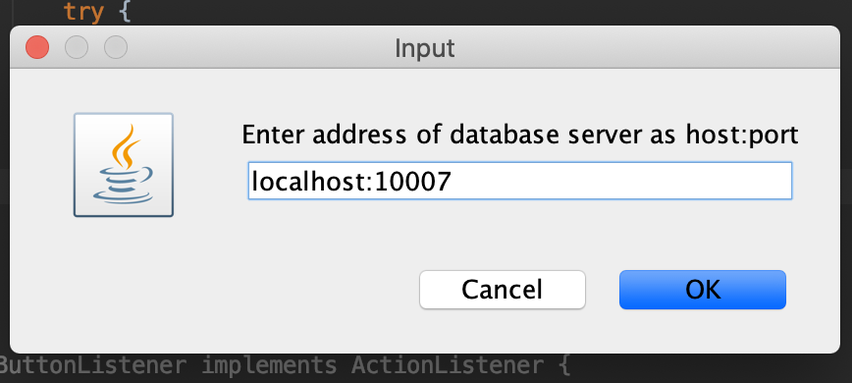

Login with user(customer) information:

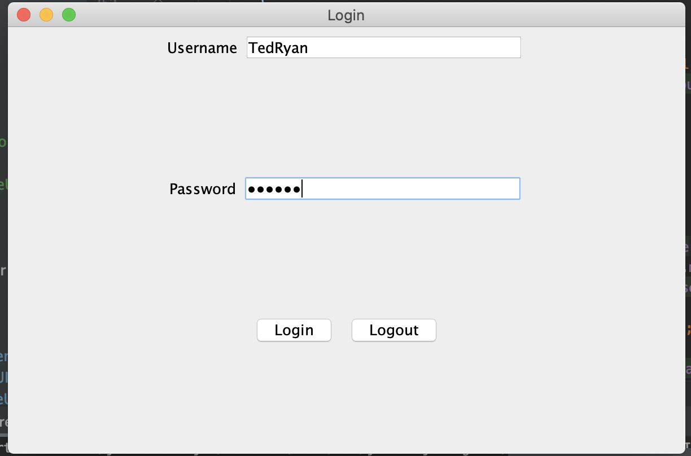

Login Granted:

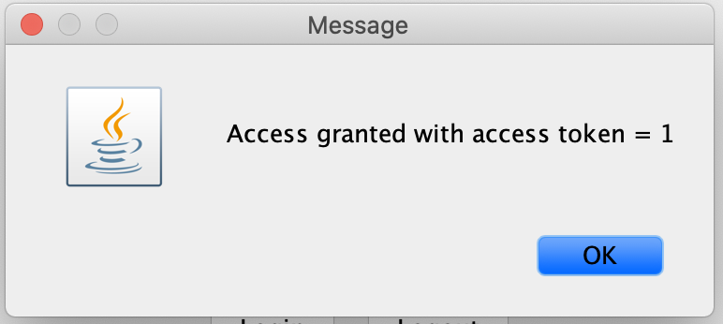

Display Customer UI:

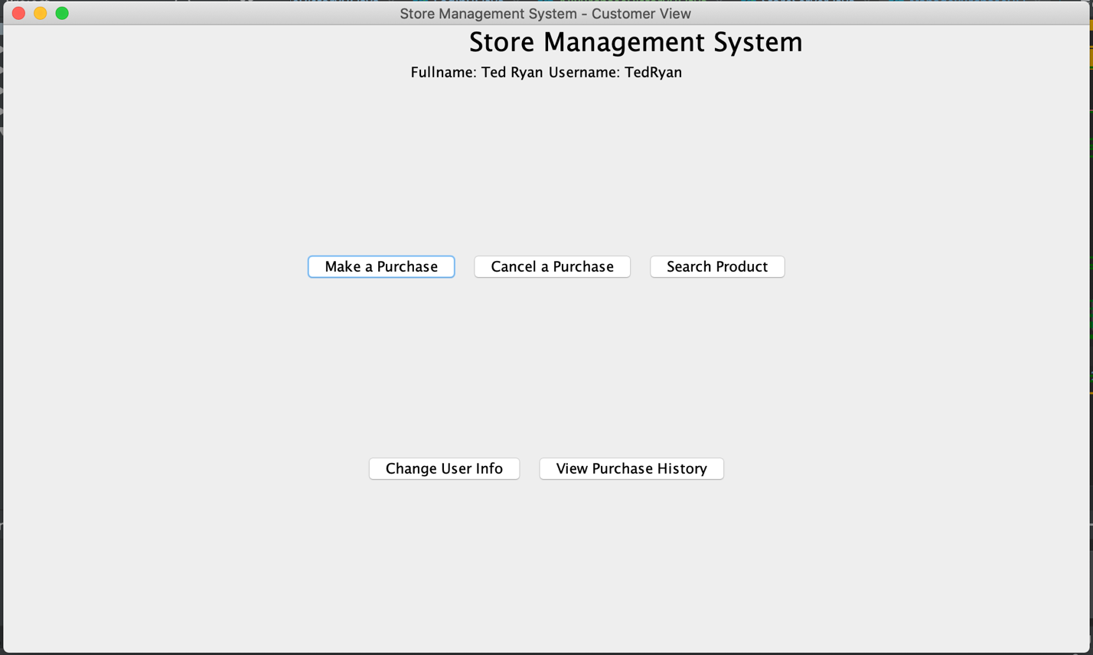

Click on Change User Info and Display Change User Info UI:

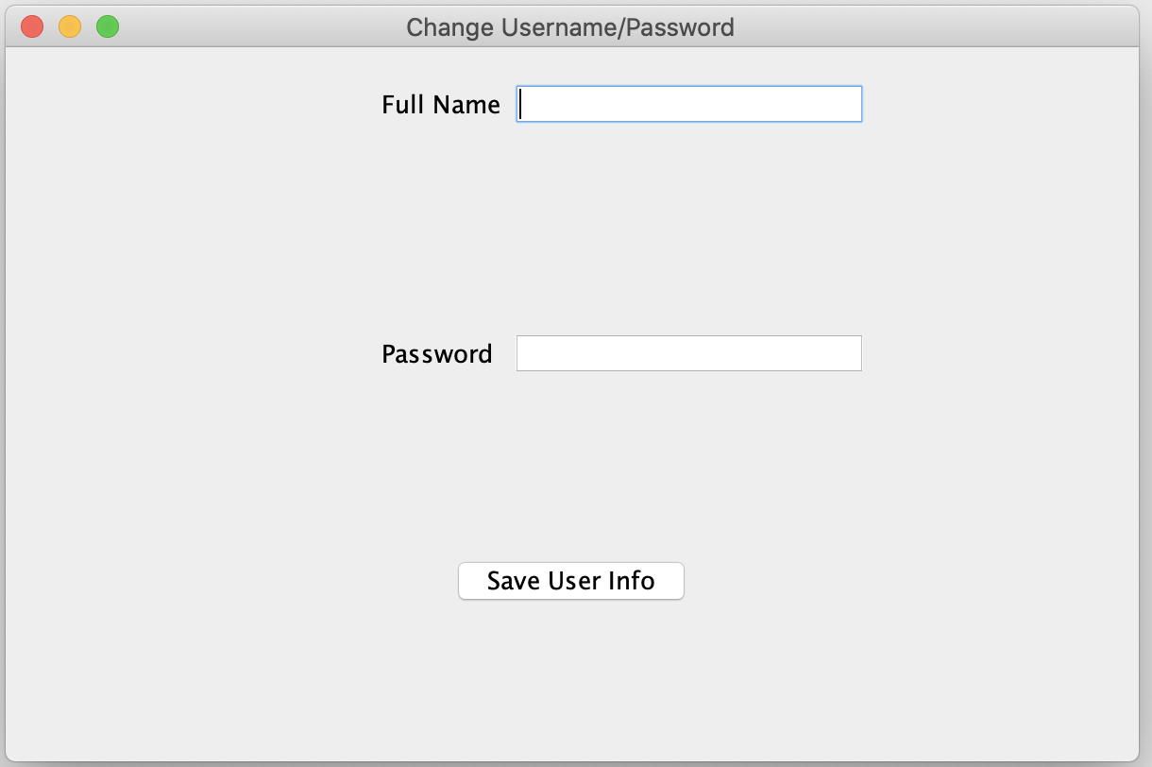

Input Information and click on Save User Info:

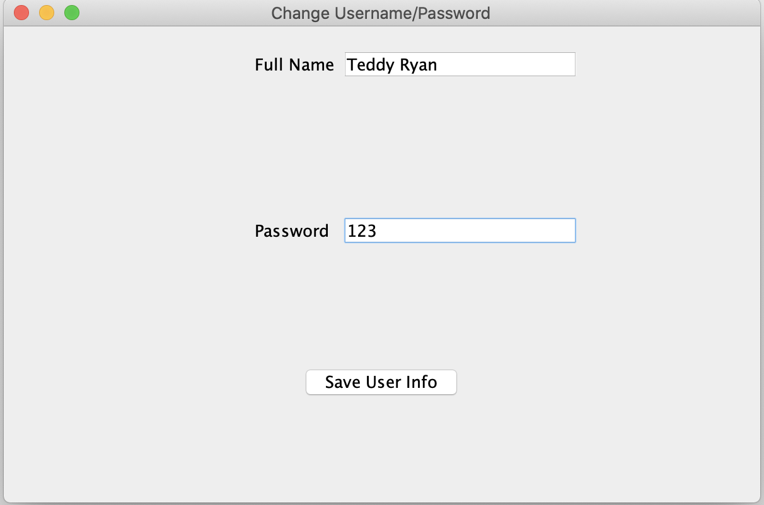

Display User Saved Successfully Message:

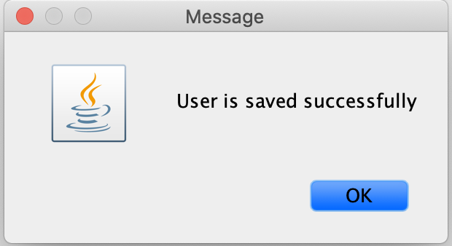

After Clicking Ok, Goes back to Changer Info Screen for further changes to the user information if necessary



2. Admin, add a new user into the system

Start the store server then start the store manager. Must enter in host:port to connect to server:



Login with user(admin) information:

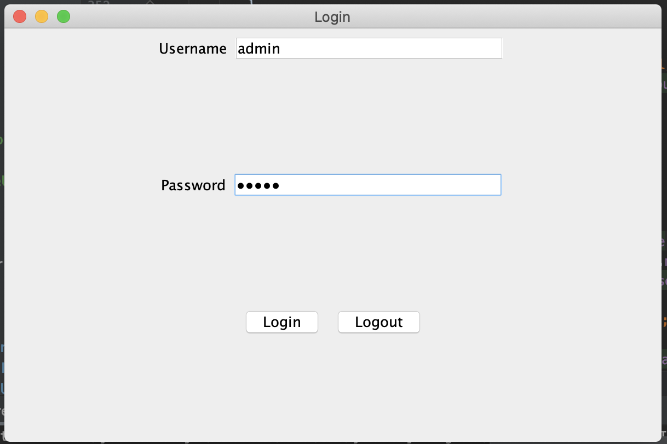

Login Granted:



Display Admin UI:

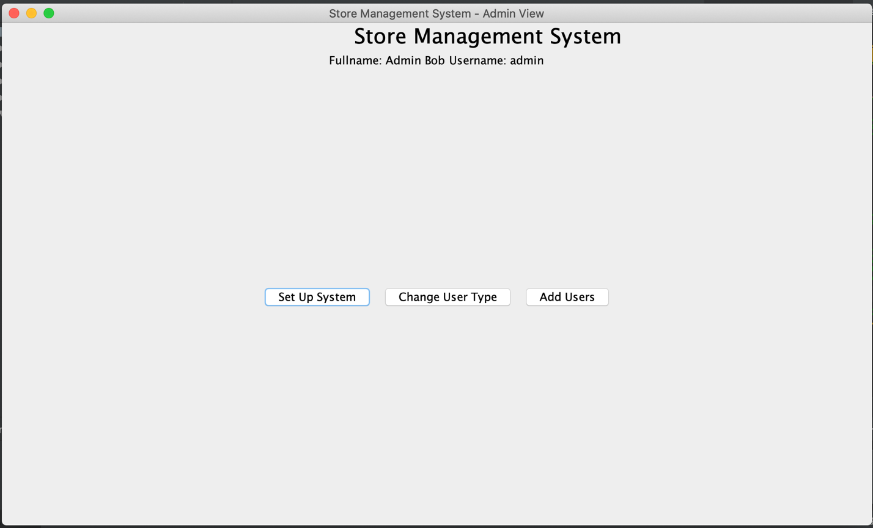

Click on Add Users and Display Add New Users Screen UI:

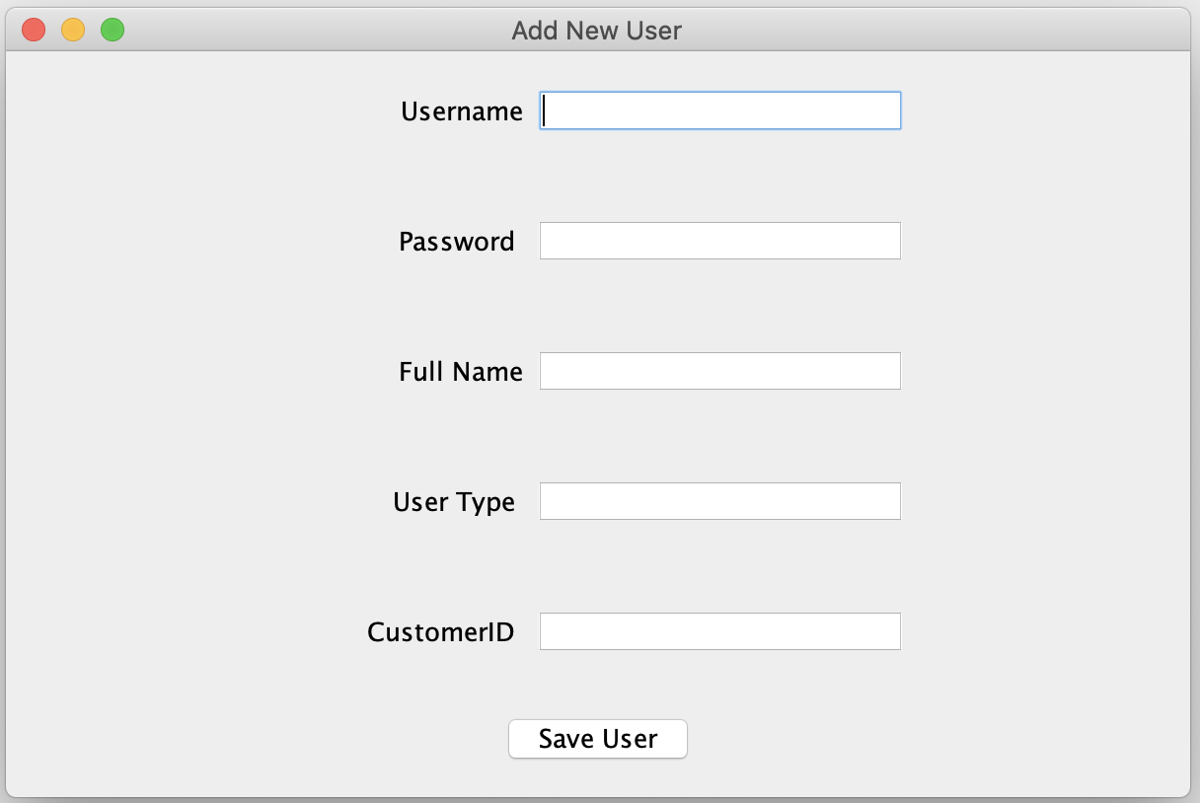

Input Information and Click on Save User (User Type 0 = Customer, 1 = Cashier, 2 = Manager, 3 = Admin:

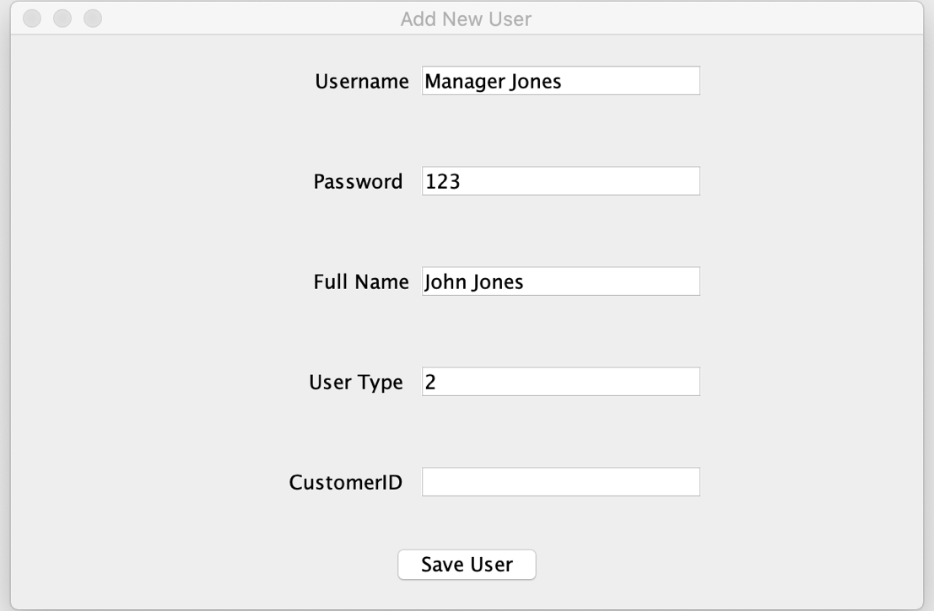

Display User Added Successful Message:

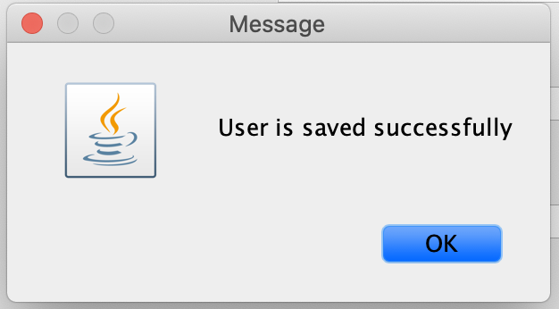

After Clicking OK, Display Add New User Screen again for further changes to system



3. As an admin, I want to update the type/class of a user into the system

Start the store server then start the store manager. Must enter in host:port to connect to server:



Login with user(admin) information:



Login Granted:



Display Admin UI:



Click on Change User Type and Change User Type UI will display:

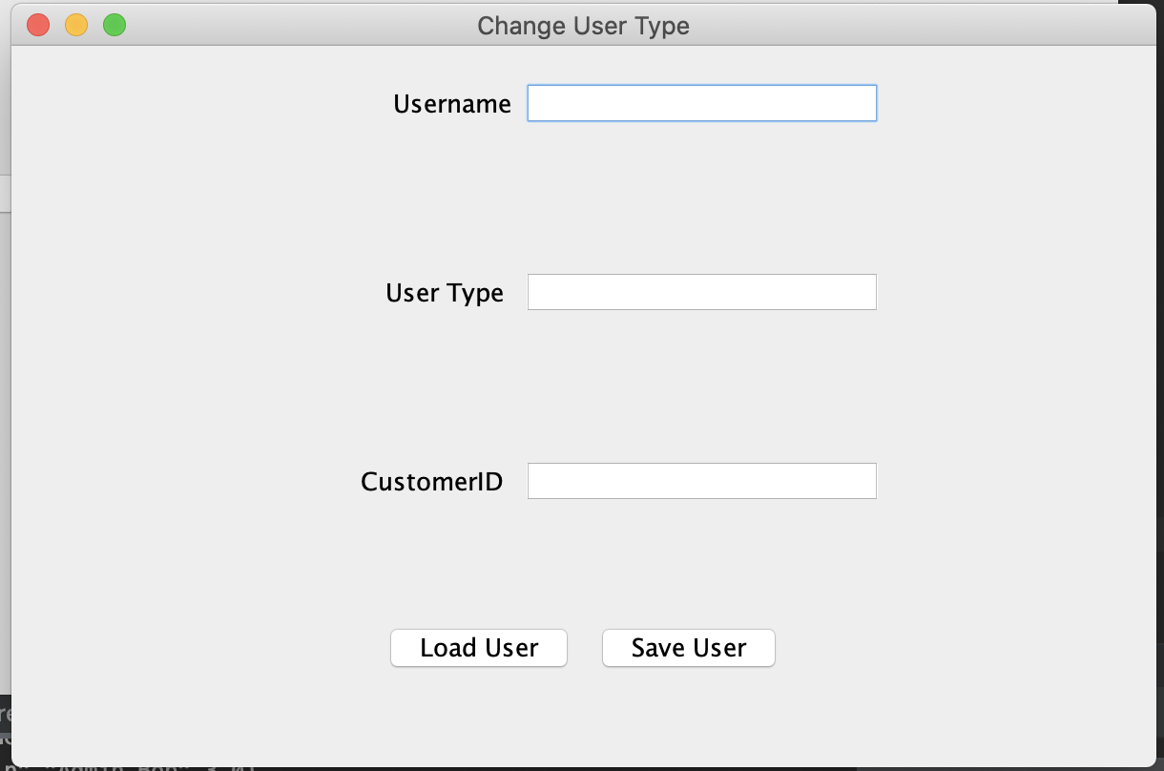

Input a Username and Click Load User:

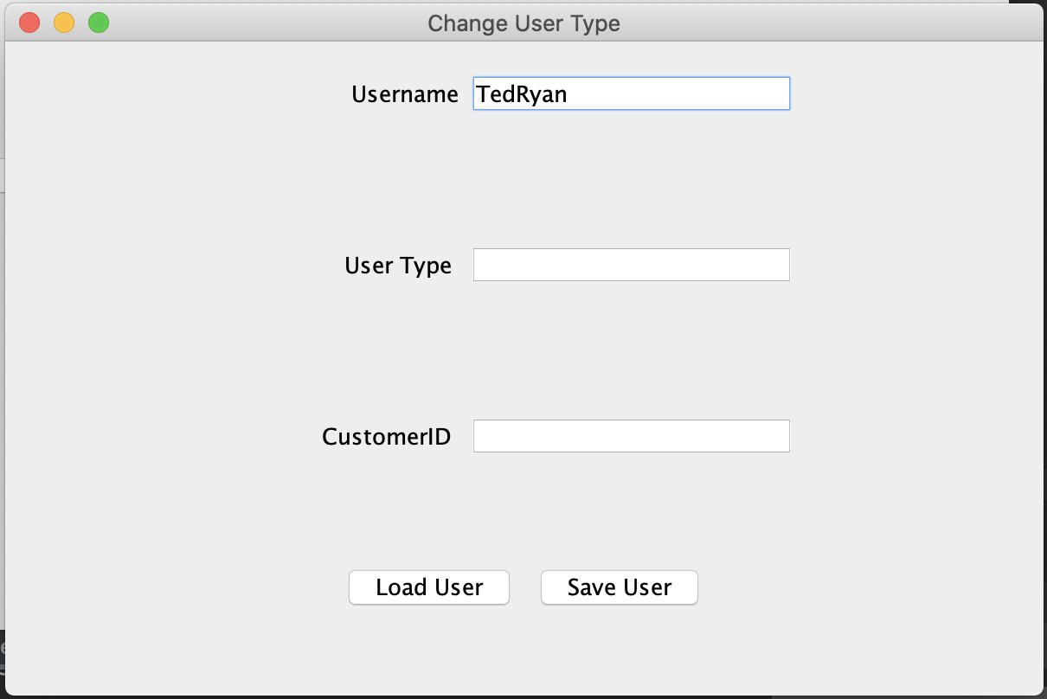

Display User Information. If User Type is not a customer, customerID field will disappear:

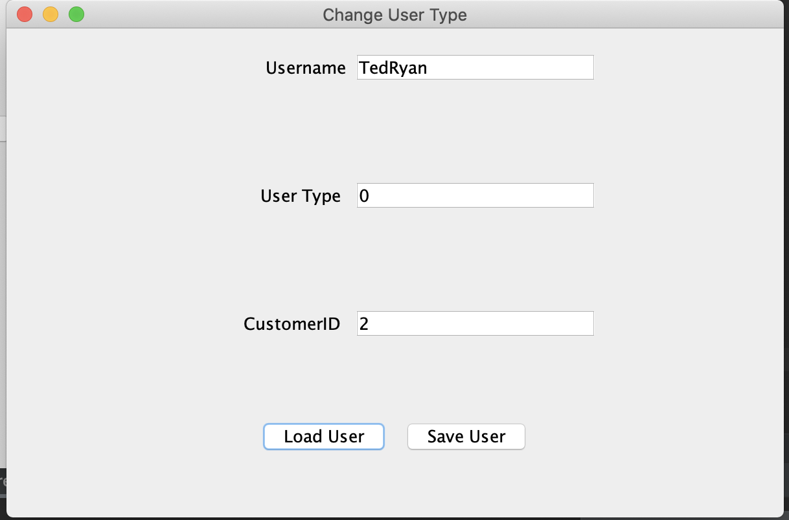

Change User from a Customer to a Cashier by changing User Type from 0 to 1:

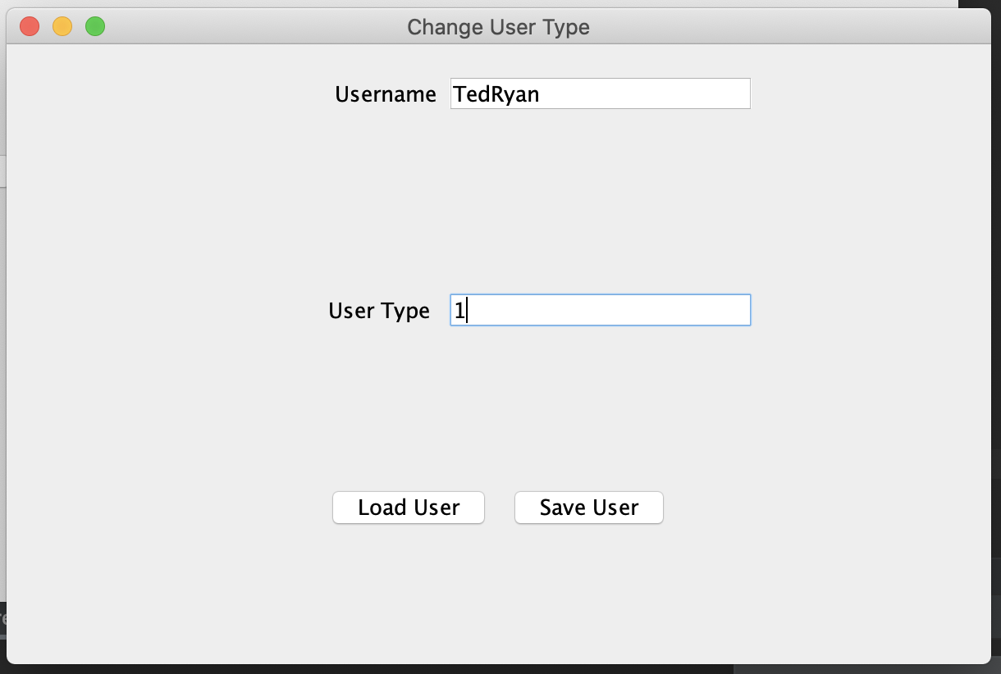

Click on Save User and display user saved successfully:

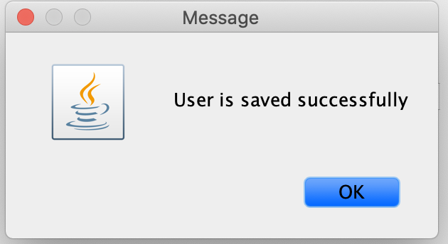

How information will be updated in the system with server and SQL commands:

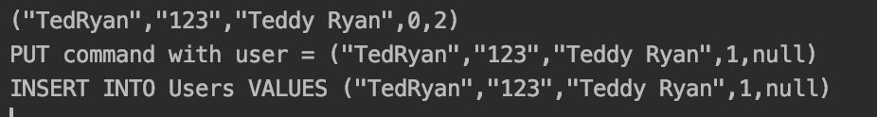

4. As a manager, I want to add a new product or update a current product in the system:

A. Add New Product Screenshots

Start the store server then start the store manager. Must enter in host:port to connect to server:



Login with user(manager) information:

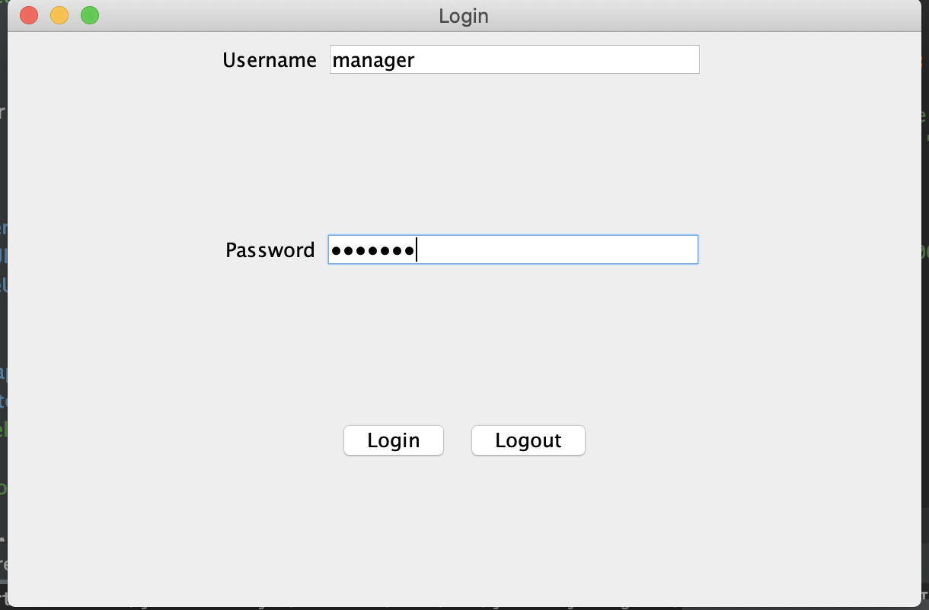

Login Granted:



Displayed Manager UI and click on Manage Products:

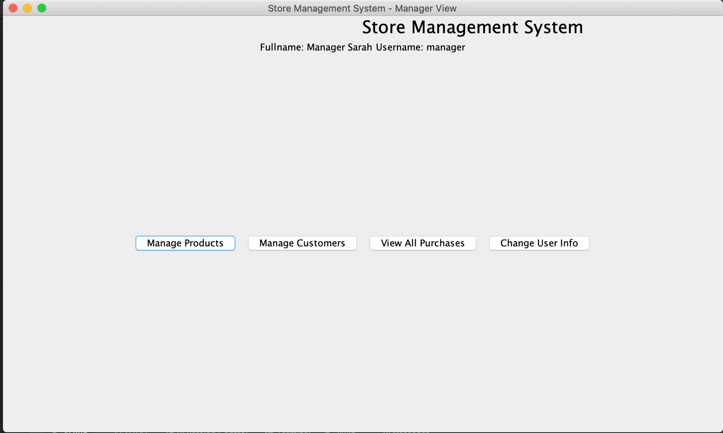

Fill in Product Information

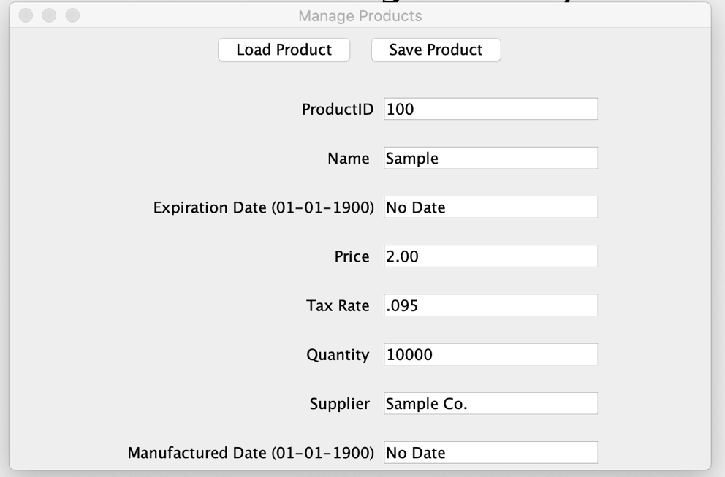

After Clicking On Save Product. Shows Product saved successfully message

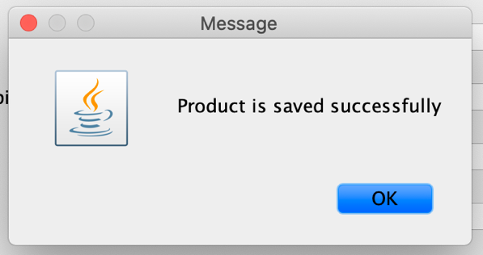

After Clicking Ok, Goes back to manage products for further changes to the system such as adding another product

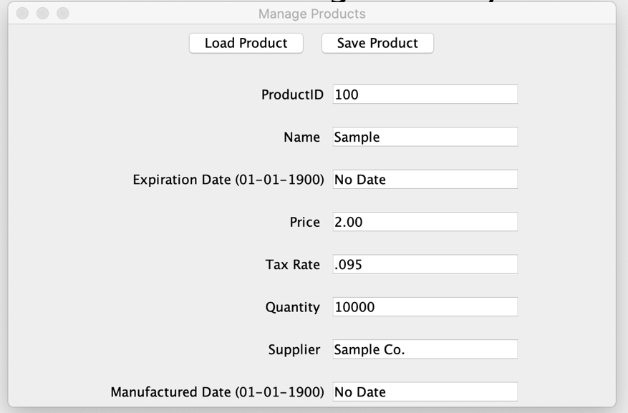

B. Update an existing product

Start the store server then start the store manager. Must enter in host:port to connect to server:



Login with user(manager) information:



Login Granted:



Displayed Manager UI and click on Manage Products:



Type in a product id and press load product button:

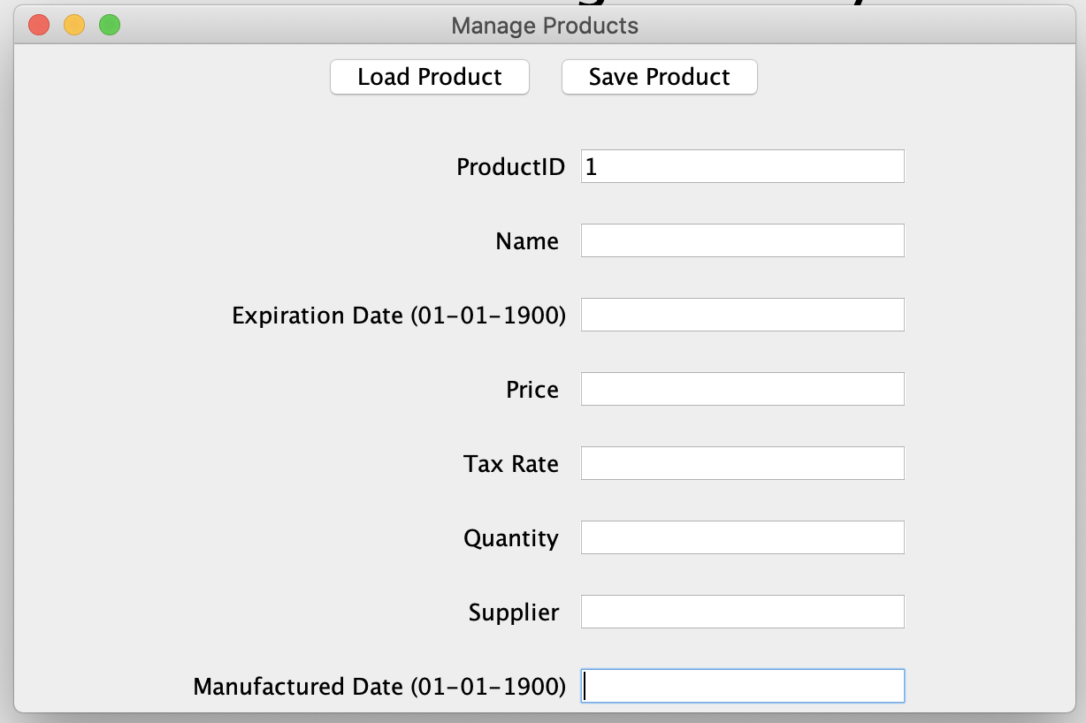

System displays product information:

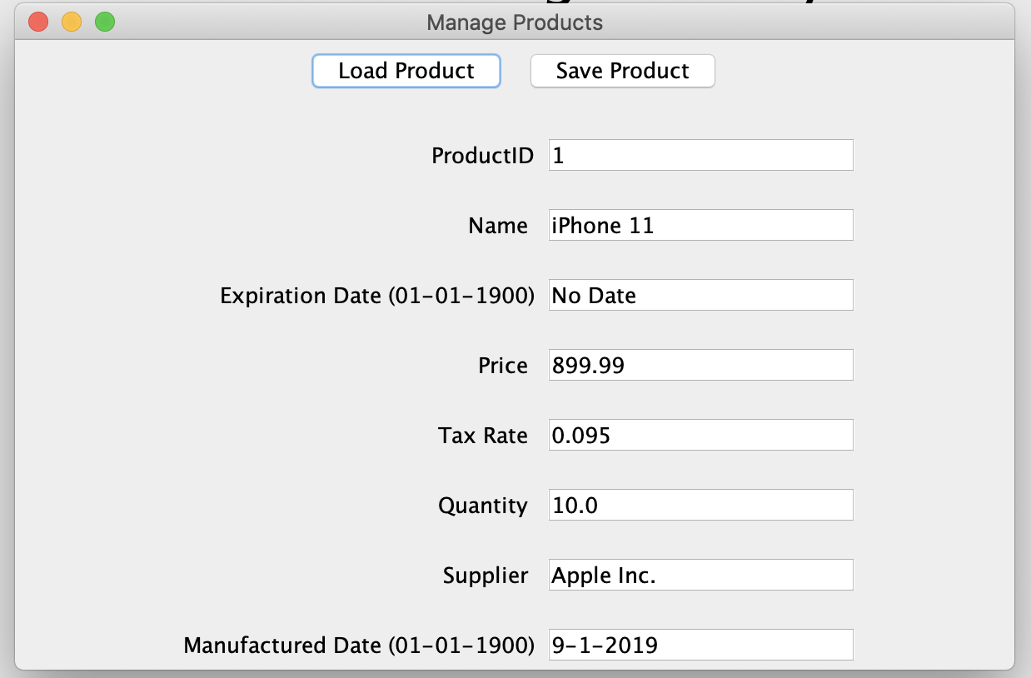

Update the product information: Changed price from 899.99 to 999.99

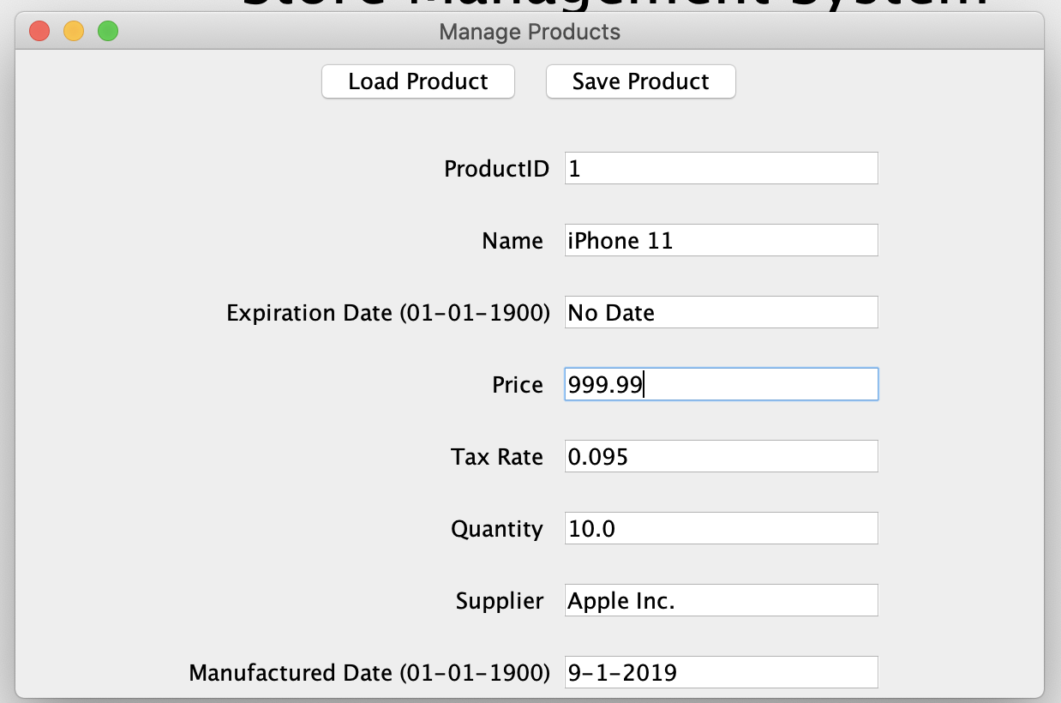

Click on save product and successful message will display:



After Clicking Ok, goes back to manage products for further changes to the system such as adding another product



5. As a manager, I want to view a summary report of sales from the system

Start the store server then start the store manager. Must enter in host:port to connect to server:



Login with user(manager) information:



Login Granted:



Displayed Manager UI and click on View All Purchases:



Display Purchase History UI for the Store:

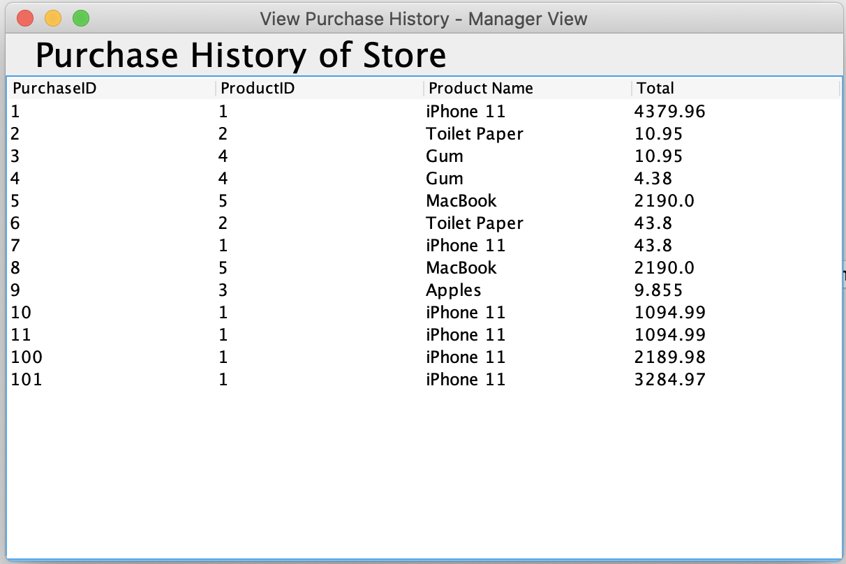

6.a Cashier wants to add a new customer to the system

Start the store server then start the store manager. Must enter in host:port to connect to server:



Login with user(cashier) information:

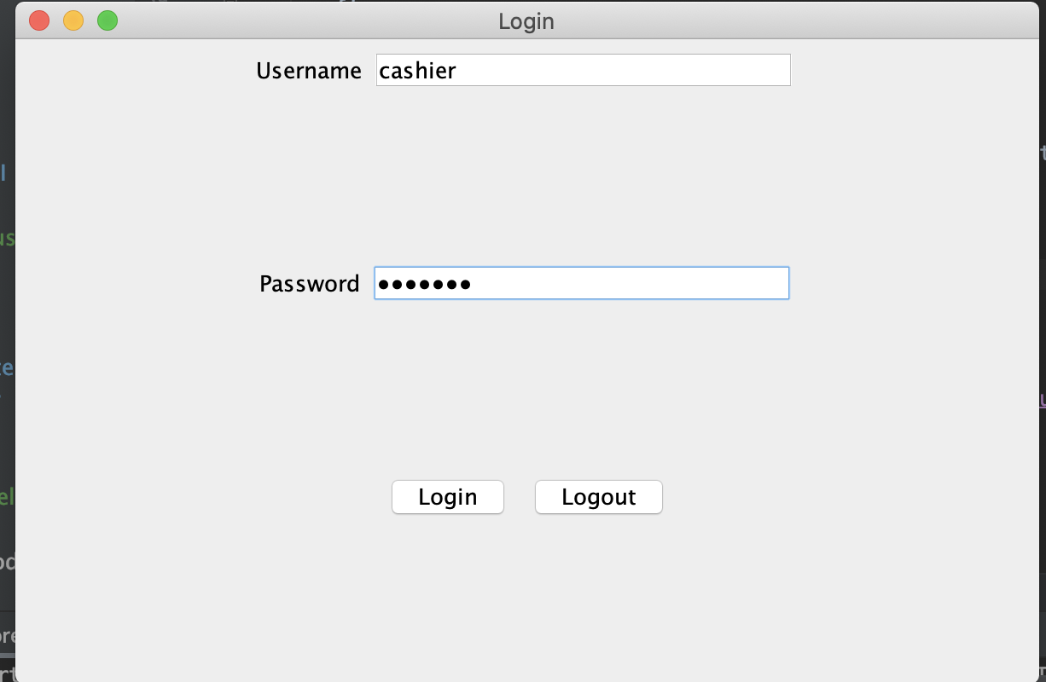

Login Granted:



Displayed Cashiier UI and click on Manage Customer:

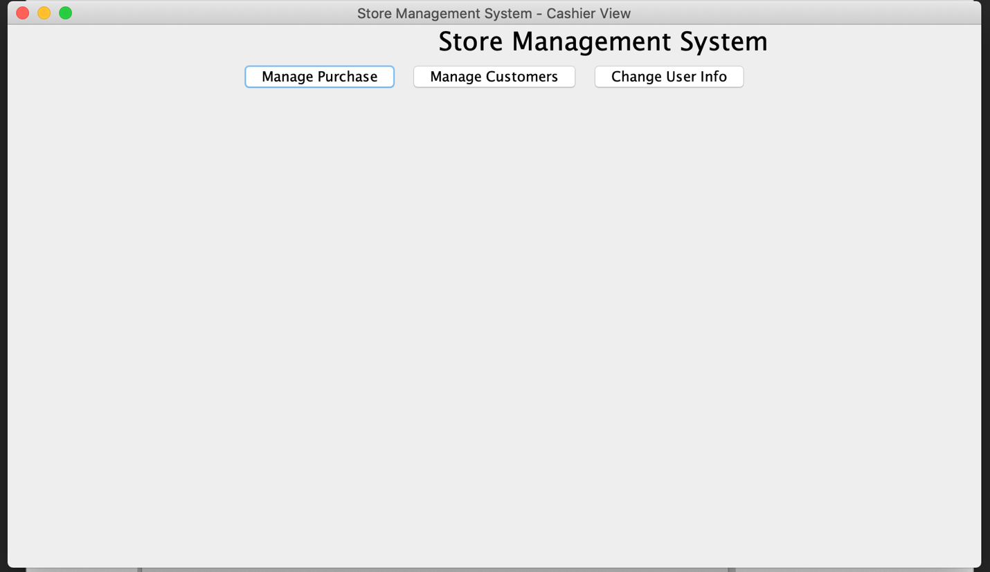

Fill in Customer Information:

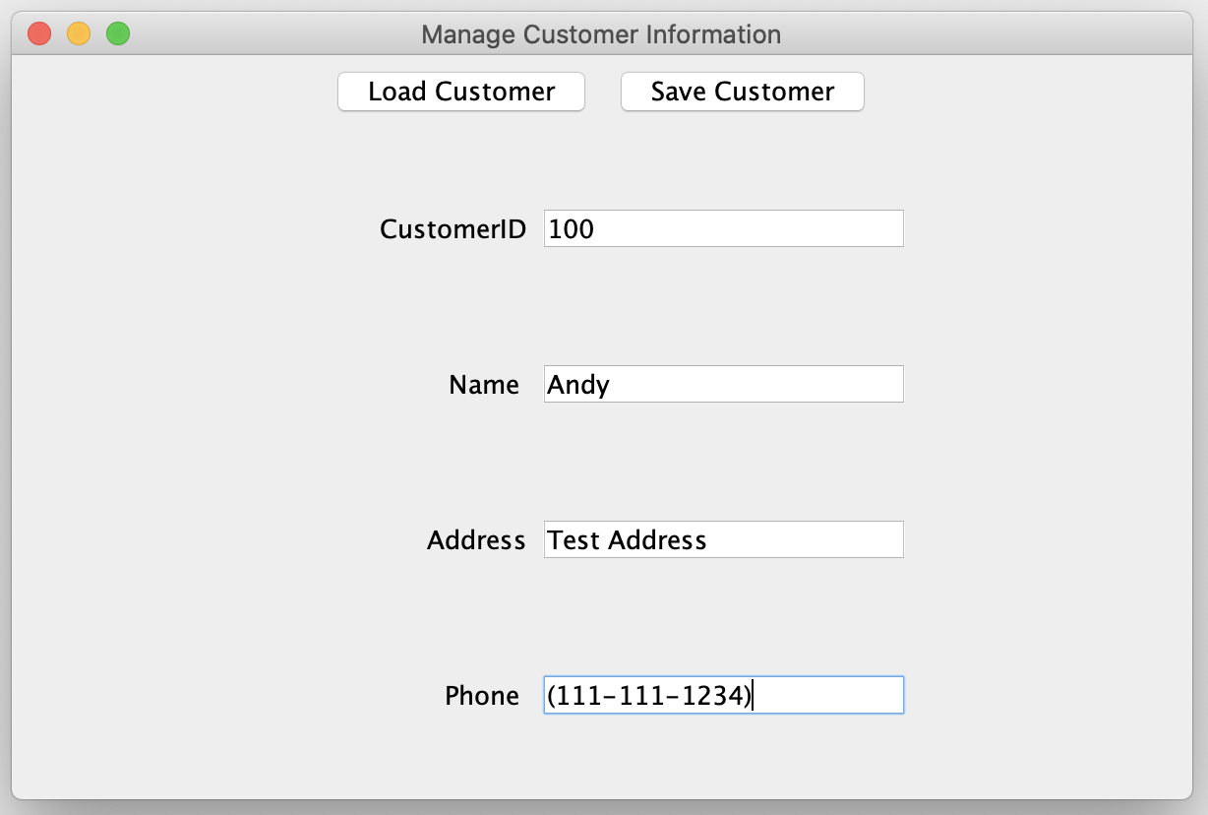

After Clicking on save, customer save successful message shows up:

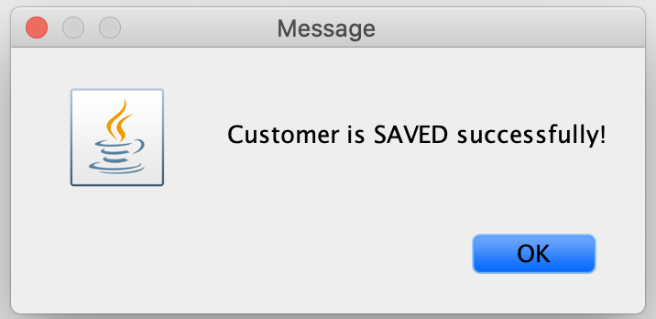

Click OK and it takes you back to manage customers for further updates to the system:



6.b Cashier wants to update Current Customer:

Start the store server then start the store manager. Must enter in host:port to connect to server:



Login with user(cashier) information:



Login Granted:



Displayed Cashier UI and click on Manage Customer:



Type in a customer id and press load:

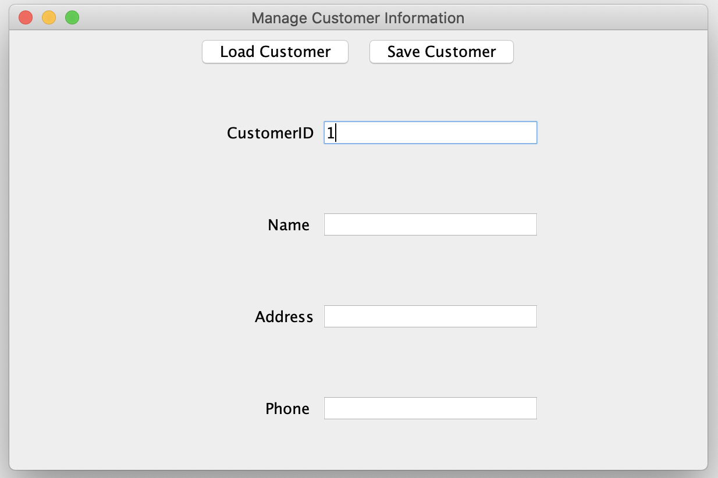

System Displays Customer Information on Screen:

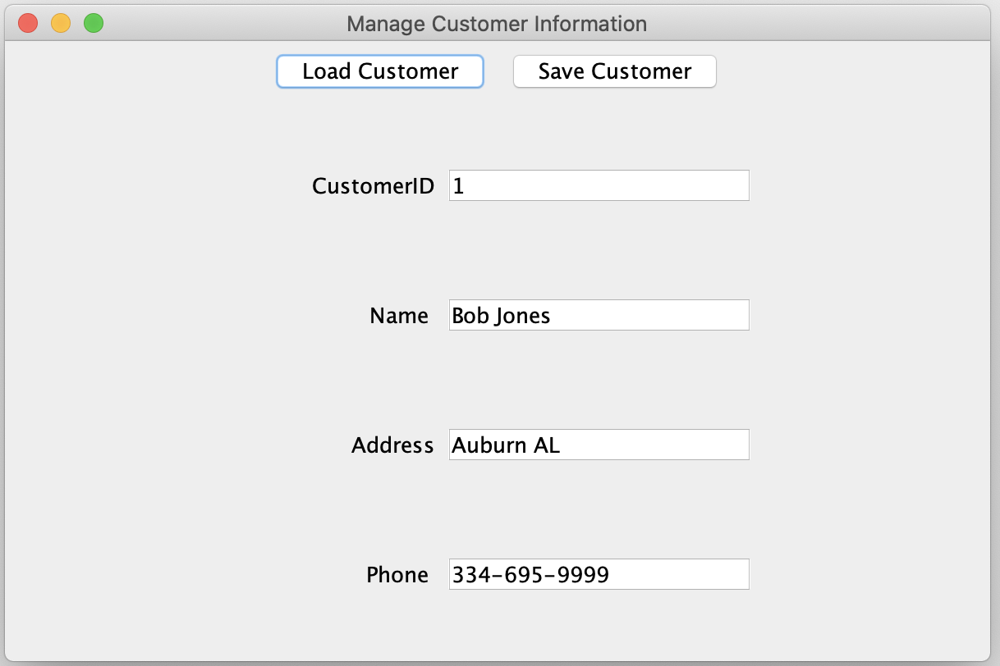

Update customer information such as changing the number for the customer:

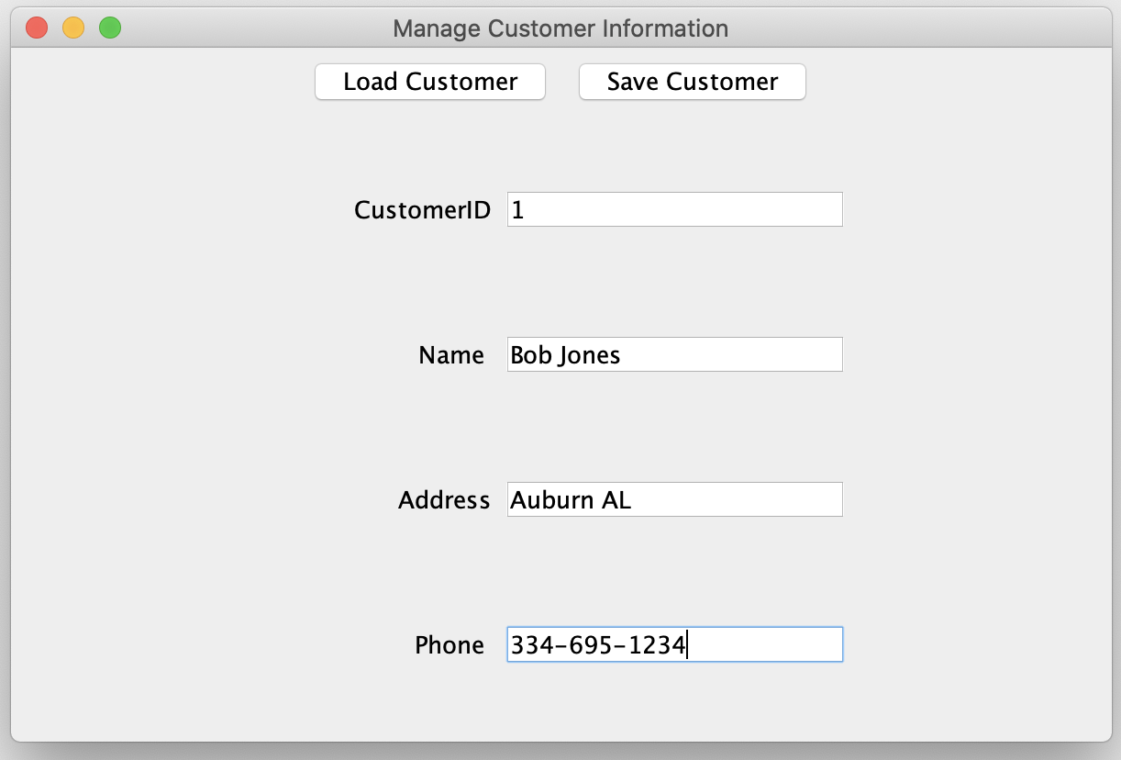

Click on save customer and successful message will show up:



Click Ok and it takes you back the manage customers screen



7.a Cashier add a new Purchase:

Start the store server then start the store manager. Must enter in host:port to connect to server:



Login with user(cashier) information:



Login Granted:



Displayed Cashier UI and click on Manage Purchases:



Display Update Purchase UI and Fill in purchase information:

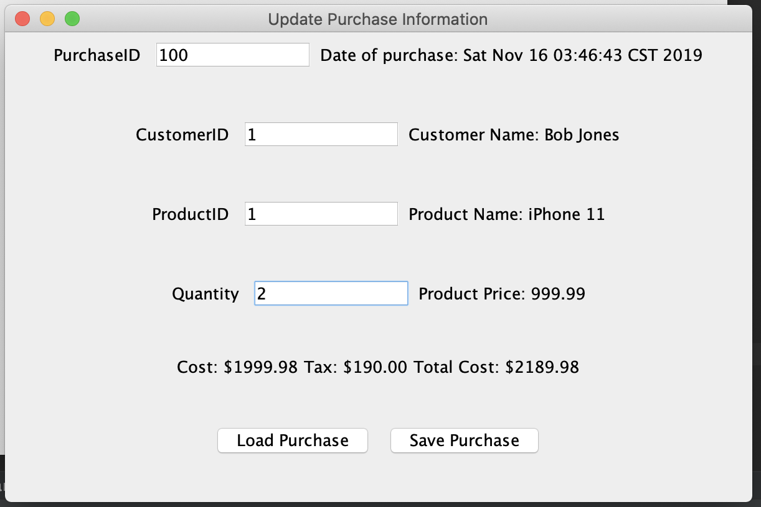

After clicking on save purchase and a successful purchase saved message pops up:

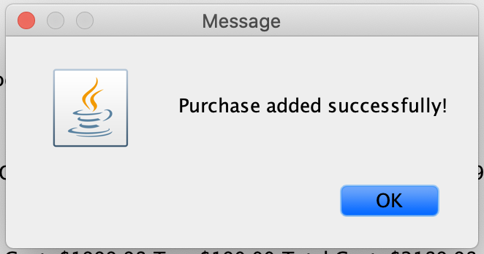

Click OK and it takes you back to manage purchase screen for further updates to the system:



7.b Update an existing purchase in the system:

Start the store server then start the store manager. Must enter in host:port to connect to server:



Login with user(cashier) information:



Login Granted:



Displayed Cashier UI and click on Manage Purchases:



Type in a purchase id and press load:

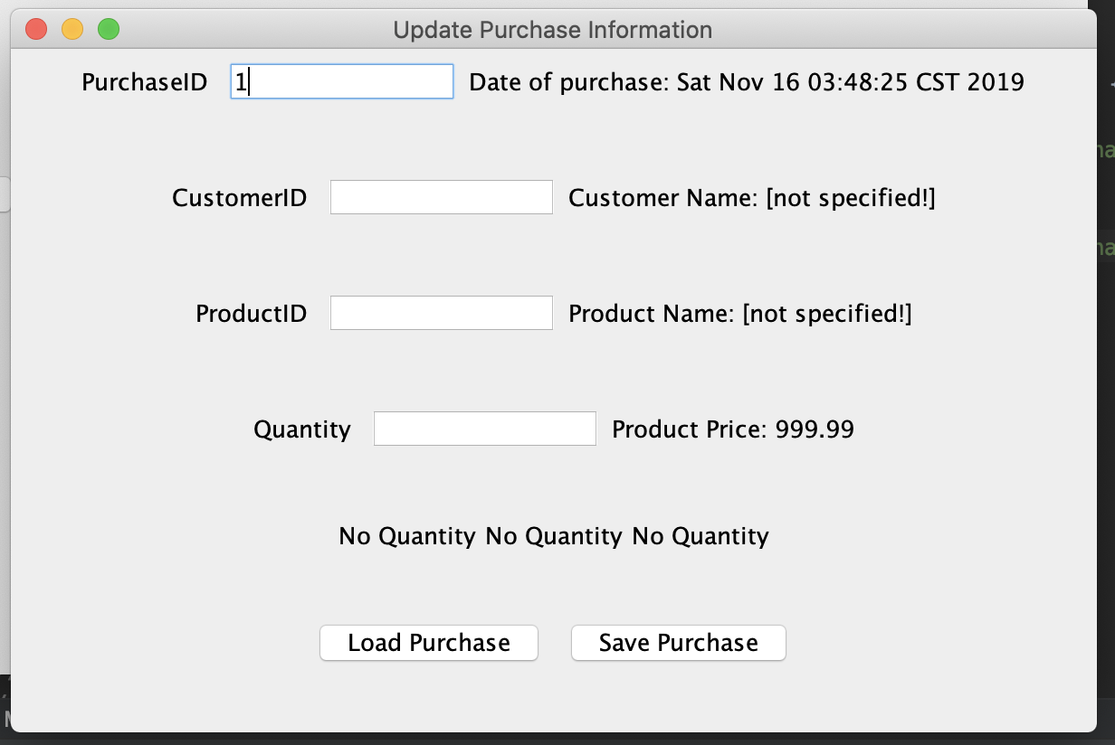

Screen with purchase information after loading:

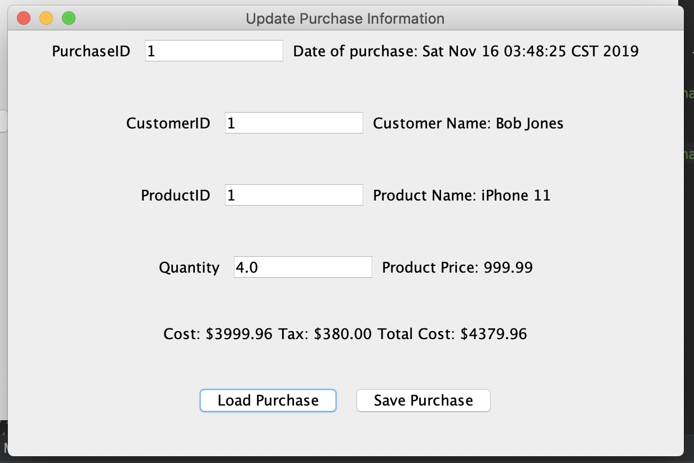

Update purchase information such as changing the quantity:

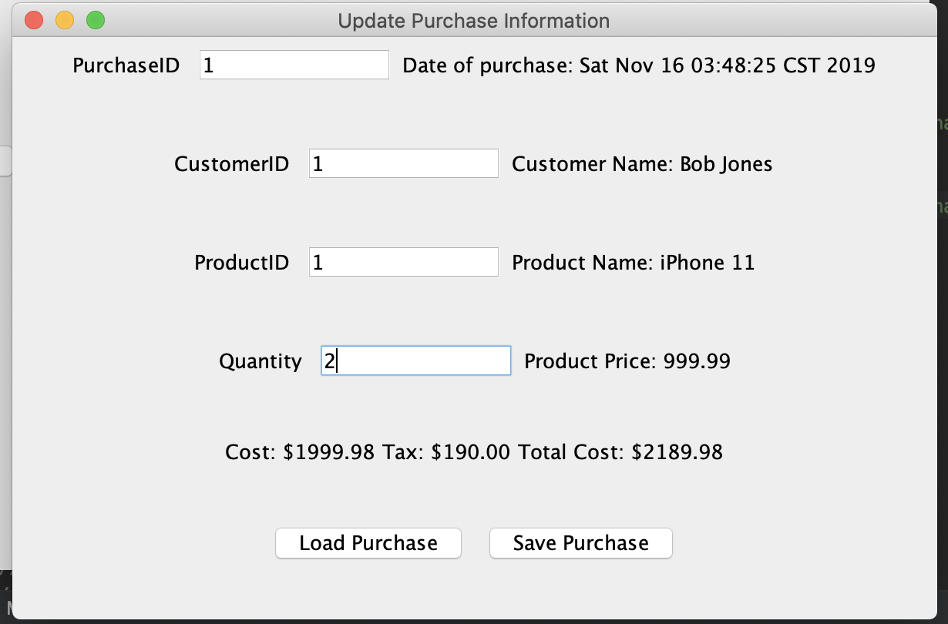

After clicking on save purchase, a successful purchase saved message pops up:



After clicking ok, the manage purchase screen shows up again for further updates:



8. Customer wants to add a purchase into the system

Start the store server then start the store manager. Must enter in host:port to connect to server:



Login with user(customer) information:

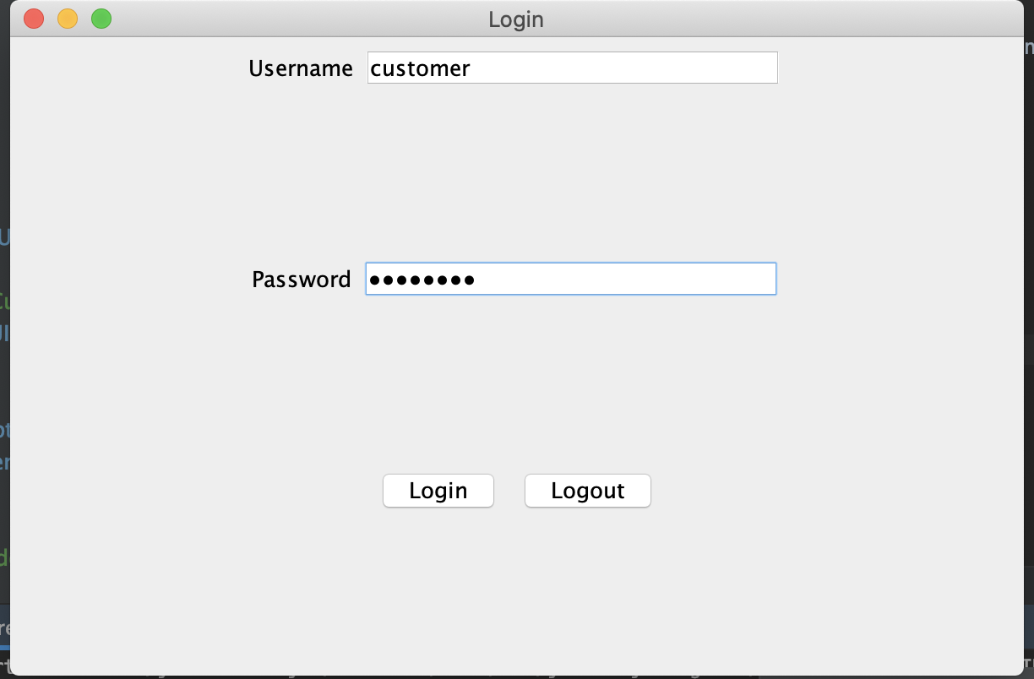

Login Granted:



Displayed Customer UI and click on Make a Purchase:

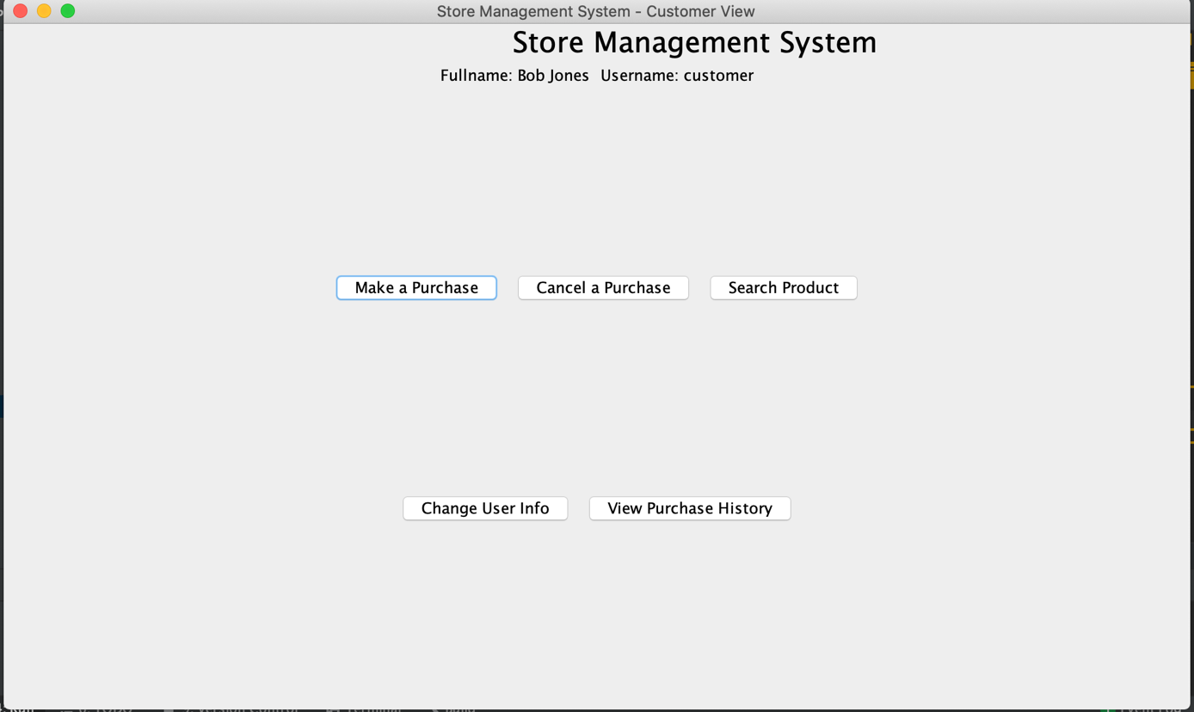

Make a Purchase screen with CustomerID already set:

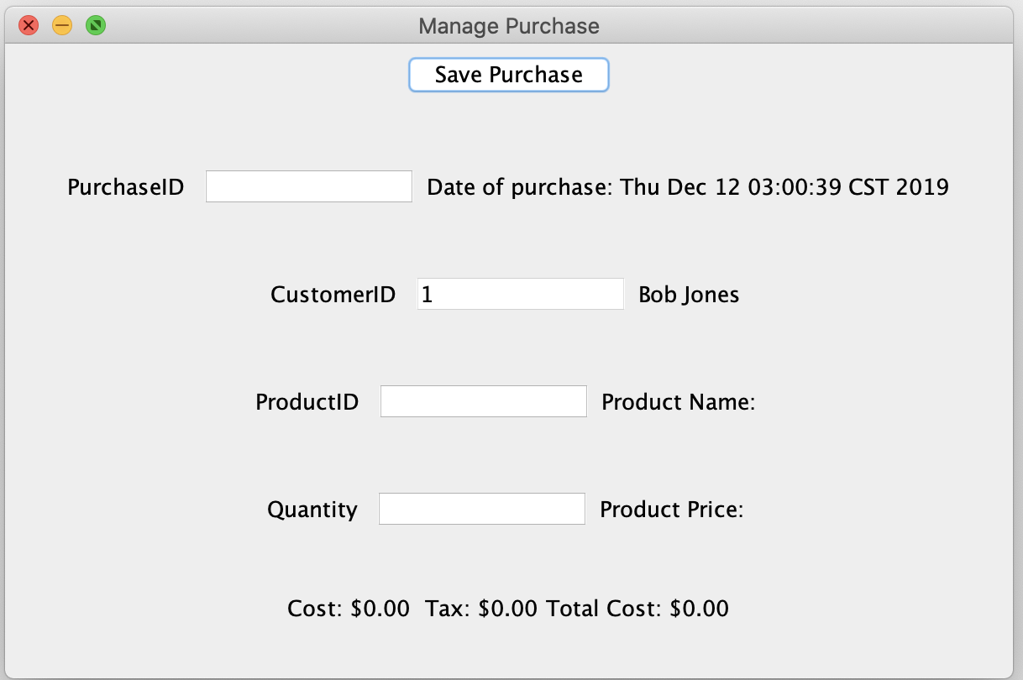

Input in the information and click save purchase:

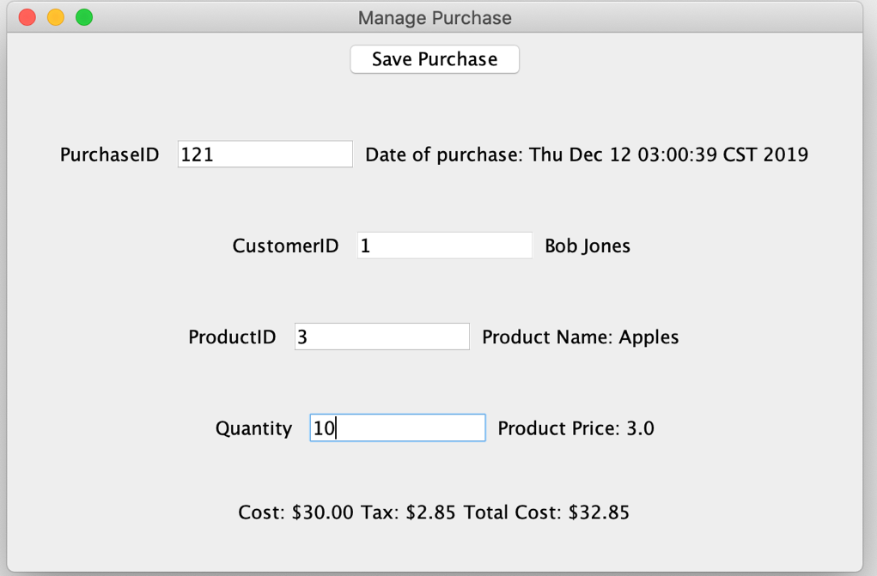

Display save successful purchase screen:

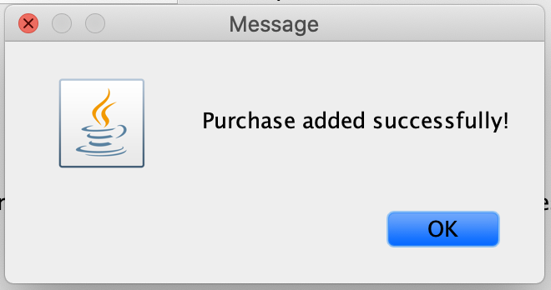

Go back to purchase screen for further updates:



9. Customer wants to view purchase history

Start the store server then start the store manager. Must enter in host:port to connect to server:



Login with user(customer) information:



Login Granted:



Displayed Customer UI and click on View Purchase History:



Display User Purchase History:

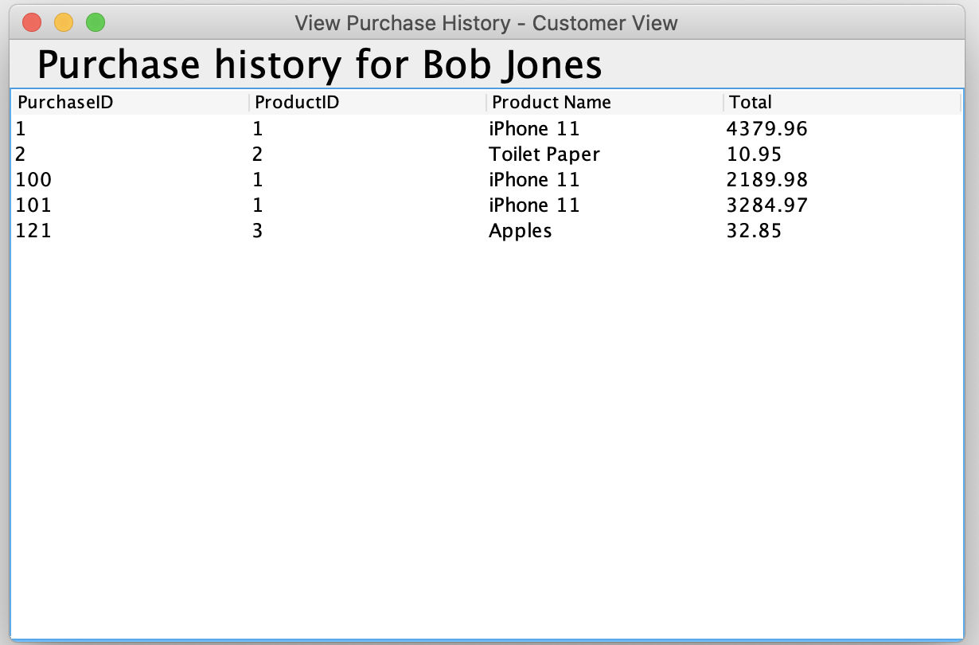

10. Customer searches for products

Start the store server then start the store manager. Must enter in host:port to connect to server:



Login with user(customer) information:



Login Granted:



Displayed Customer UI and click on Search Product:



Display Search Product Input UI:

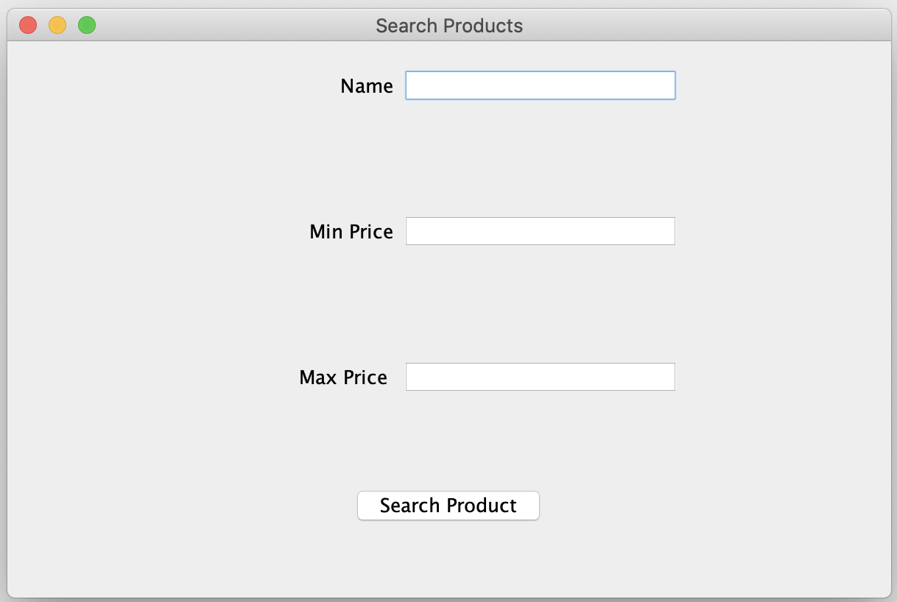

Enter Information and Click Search Product:

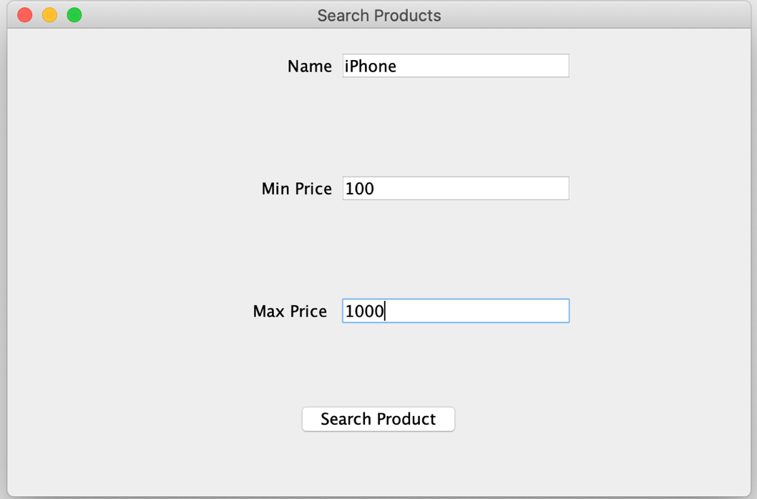

Display Search Results:

